Divyadharshini T

KSECE

Single inheritance:

Source code:

class student{

float mark=80;

}

public class Main extends student{

int internal=10;

public static void main(String args[]){

Main c=new Main();

System.out.println("student mark is:"+c.mark);

System.out.println("student internal is:"+c.internal);

}

}

Code with output:

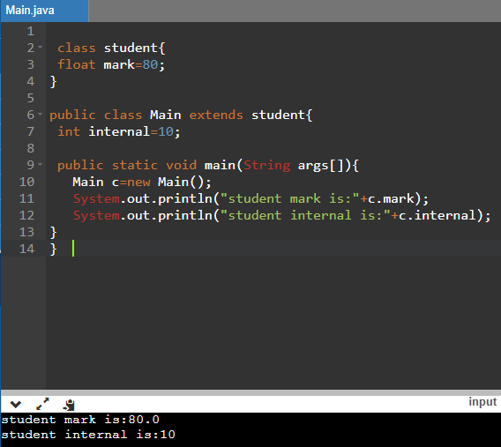

Multilevel Inheritance:

Source code:

class A{

int a = 10;

void show() {

System.out.println("a = "+a); }

}

class B extends A{

int b = 10;

void showB() {

System.out.println("b = "+b);

}

}

public class Main extends B{

public static void main(String[] args) {

Main c = new Main();

c.show();

c.showB();

}

}

Code with output:

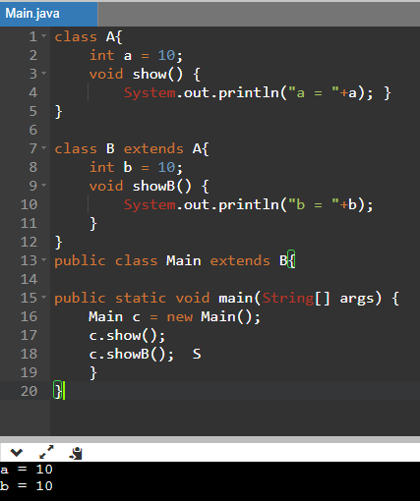

Hierarchical Inheritance:

Source code:

class A{

int a = 10;

void show() {

System.out.println("a = "+a);

}

}

class B extends A{

int b = 10;

void showB() {

System.out.println("b = "+b);

}

}

public class Main extends A{

public static void main(String[] args) {

Main c = new Main();

c.show();

B b = new B();

b.show();

}

}

Code with output:

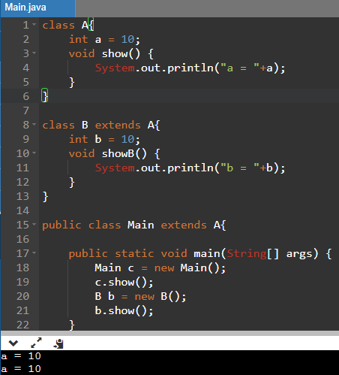

Using super key:

Source code:

class Parent

{

String name;

}

public class Main extends Parent {

String name;

public void details(){

super.name = "Parent";

name = "Child";

System.out.println(super.name+" and "+name);

}

public static void main(String[] args)

{

Main cobj = new Main();

cobj.details();

}

}

Code with output:

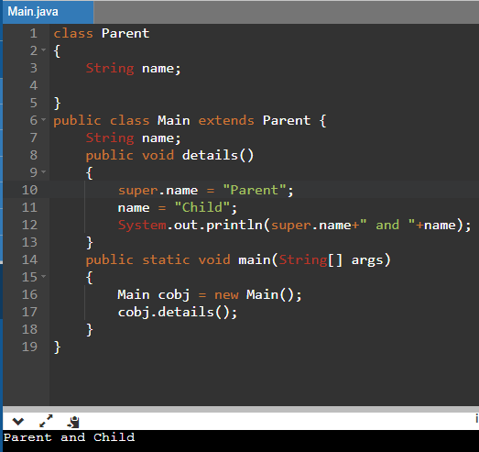

Polymorphism:

Source code:

class Polygon {

public void render() {

System.out.println("Rendering Polygon..."); }

}

class Square extends Polygon {

public void render() {

System.out.println("Rendering Square..."); }

}

class Circle extends Polygon {

public void render() {

System.out.println("Rendering Circle...");

}

}

class Main {

public static void main(String[] args) {

Square s1 = new Square();

s1.render();

Circle c1 = new Circle();

c1.render();

}

}

Source code with output:

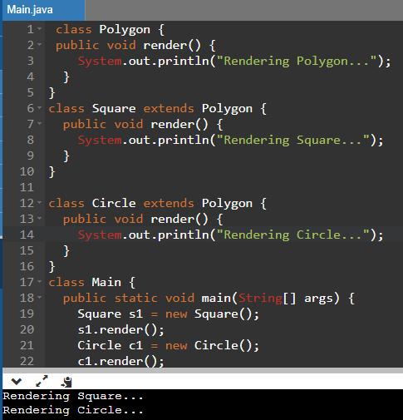

Abstract:

Source code:

abstract class Mytest {

abstract void calculate(int a, int b); }

class Addition extends Mytest {

void calculate(int a, int b) {

int x = a + b;

System.out.println("Sum: " +x); } }

class Subtraction extends Mytest {

void calculate(int a, int b){

int y = a - b;

System.out.println("Subtract: " +y); } }

class Multiplication extends Mytest {

void calculate(int a, int b) {

int z = a \* b;

System.out.println("Multiply: " +z); } }

public class Main {

public static void main(String[] args) {

Addition a = new Addition();

Subtraction s = new Subtraction();

Multiplication m = new Multiplication();

a.calculate(20, 30);

s.calculate(10, 5);

m.calculate(10, 20); } }

Source code With output:

